U N I T E D N A T I O N S 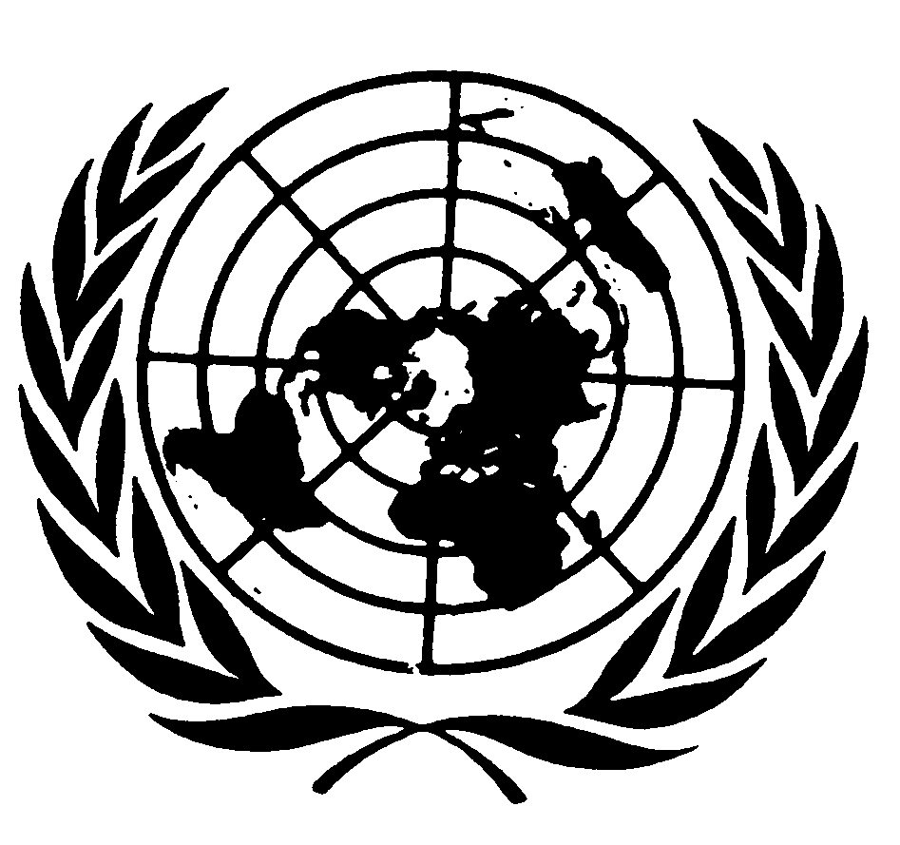 N A T I O N S U N I E S

DIRECTOR-GENERAL’S DRAFT REMARKS FOR THE OPENING OF THE “MAN AND NATURE” ART EXHIBITION , 3 JUNE 2013

Mr. Zhang Lei, Deputy Permanent Representative of the People’s Republic of China,
Mr. Dong Xiyuan [pronounced Shi-un],
UN Colleagues,
Dear Guests,
Ladies and gentlemen,

I am pleased to be with you today for the opening of this exhibition by the Chinese artist Mr. Dong Xiyuan, with the theme of “Man and Nature”. I am grateful to the Permanent Mission of the People’s Republic of China and to the UN Environment Programme (UNEP) for organizing this event, and for bringing these wonderful works of art to the UN Office at Nairobi (UNON).
Mr. Xiyuan is a true advocate of the environment. He uses traditional Chinese ink and brush techniques to highlight the beauty of nature, and to explore the interaction between human beings and our natural environment.

UNON is a very appropriate venue for this exhibition. As you know, Nairobi is the global headquarters for UNEP, which recently held its first universal session of its Governing Council, in accordance with the decision of the United Nations Conference on Sustainable Development held in Rio last year. With the upgrading to universal membership, we can now say that Nairobi is indeed the environmental capital of the world.

The exhibition is also very timely. In two days, we will be marking the United Nations World Environment Day - a day for action to improve the environment now and for the future.
In his art, Mr. Xiyuan uses traditional Chinese aesthetic techniques to advocate for greater protection of the environment. The harmonious co-existence of man and nature lie at the heart of the paintings, hand-drawn plates, and porcelain vases featured in this exhibition.

Living in harmony with our natural environment is a major issue facing humanity. It is also at the center of the United Nations’ efforts to promote sustainable development around the world. At the Rio+20 Conference last year, world leaders agreed that it was necessary to promote harmony
with nature to achieve balance among the economic, social, and environmental needs of present and future generations. These are crucial concerns as we work to achieve the Millennium Development Goals by 2015, and as we develop a new global development framework for the post-2015 era.

As we view these inspiring works of art, let us be reminded of the need to develop a more ethical basis for the relationship between humanity and the Earth, with a
view to creating a better world for all.
Thank you.

